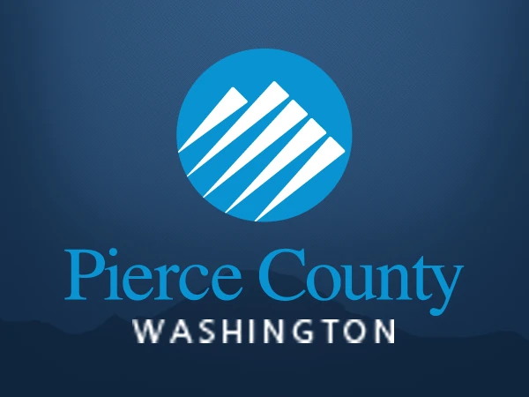

**INTRODUCTION:**

The objective of conducting this employee survey is to gather valuable feedback from our workforce regarding various aspects of our organization. By understanding their perspectives, we aim to identify strengths, areas for improvement, and opportunities to enhance overall employee satisfaction and productivity. This survey is designed for all employees across departments and levels within our organization. Their insights and opinions are crucial in shaping future strategies and initiatives that aim to create a positive and supportive work environment.

The Employee Survey Responses are actual responses from an employee engagement survey conducted by Pierce County WA and completed voluntarily by government employees. The dataset is a Single table and contains 14,725 records. The total number of fields is 10.

**PROBLEM STATEMENT:**

**Question 1.**

* Which survey questions did respondents agree with or disagree with most?

**Question 2.**

* Do you see any patterns or trends by department or role?

**Question 3.**

* As an employer, what steps might you take to improve employee satisfaction based on the survey results?

**SKILLS DEMONSTRATED:**

* Power Query
* Data Modeling
* Data Cleaning
* Data Visualization

**DATA SOURCING:**

The Dataset was provided by digitaleydrive Link to Dataset <https://docs.google.com/spreadsheets/d/1nbhfp2ModgqDAPveYQG9CknRw2PYJQxbOTs3xSKOB8E>

**DATA TRANSFORMATION:**

The data was thoroughly cleaned and transformed with Power BI's Power Query Editor. Important actions in this procedure were:

**Data Cleansing:**

* Changing null values to 0.
* Transformation of numbers based on language into numerical values.

**DATA MODELING:**

After completing the data conversion phase, I proceeded to data modeling and carefully evaluated relationships. I cleaned up the data with Power Query and then exported it into Power BI, where relationships were built without any problems.

**ANALYSIS AND VISUALIZATION: picture**

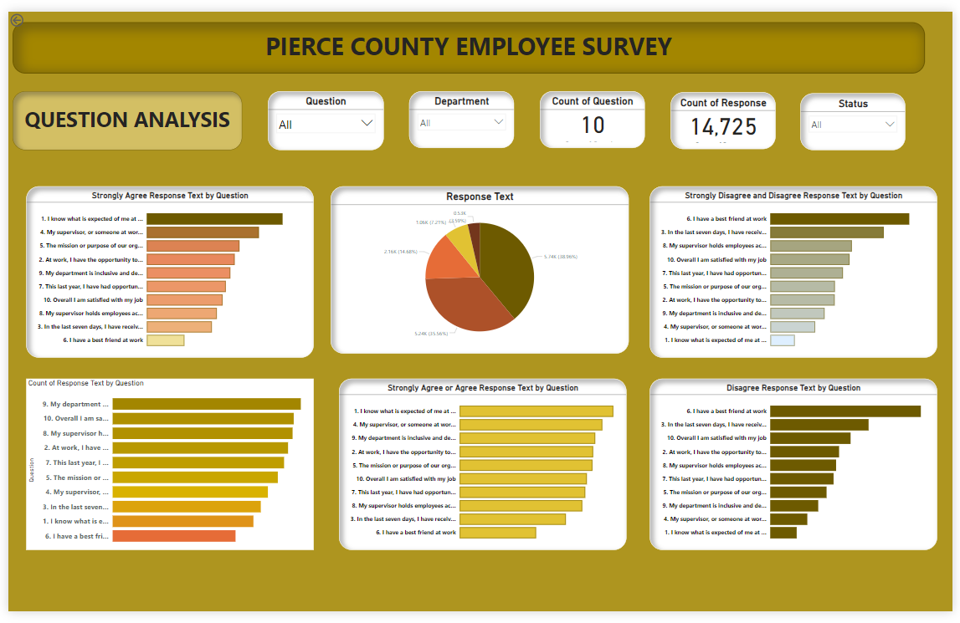

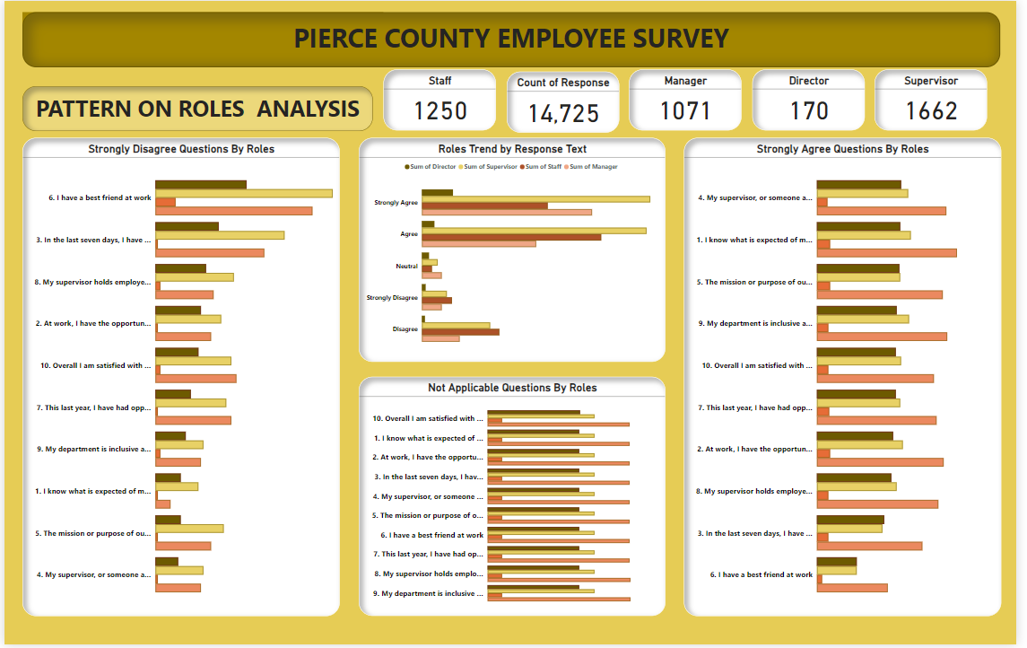

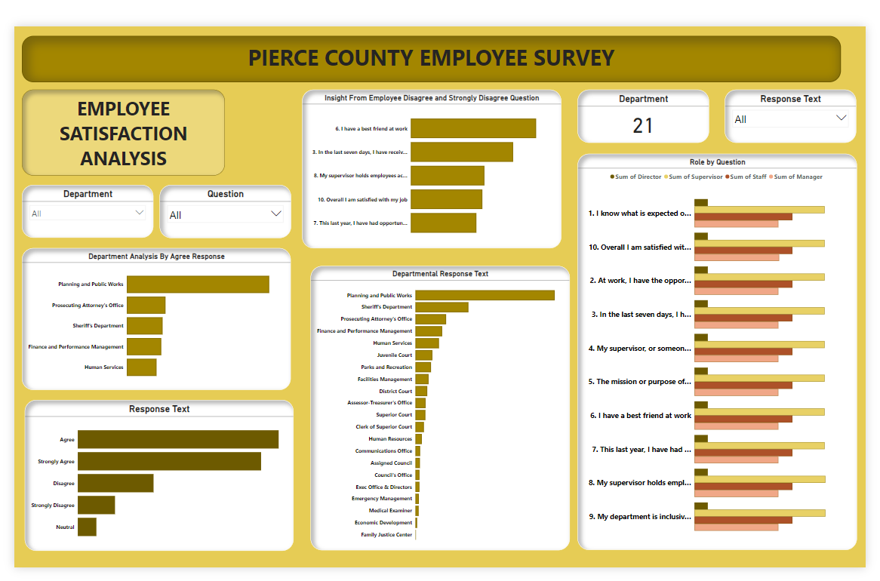

The employee response rate to the aforementioned questions is relatively high—it is not less than 600—indicating that job requirements have been communicated clearly.

Question 1: "I know what is expected of me at work"

Employees: 1,342 Agree OR Strongly Agree

Question 2: "At work, I have the opportunity to do what I do best every day"

Employees: 1,166 Agree OR Strongly Agree

Question 3: "In the last seven days, I have received recognition or praise for doing good work"

Employees: 928 Agree OR Strongly Agree

Question 4: "My supervisor holds employees accountable for performance"

Employees: 1,246 Agree OR Strongly Agree

Question 5: "The mission or purpose of our organization makes me feel my job is important"

Employees: 1,160 Agree OR Strongly Agree

Question 6: "I have a best friend at work"

Employees: 668 Agree OR Strongly Agree

Question 7: "This last year, I have had opportunities at work to learn and grow"

Employees: 1,097 Agree OR Strongly Agree

Question 8: "My department is inclusive and demonstrates support of a diverse workforce"

Employees: 1,071 Agree OR Strongly Agree

Question 9: "My supervisor, or someone at work, seems to care about me as a person"

Employees: 1,184 Agree OR Strongly Agree

Question 10: "Overall I am satisfied with my job"

Employees: 1,111 Agree OR Strongly Agree

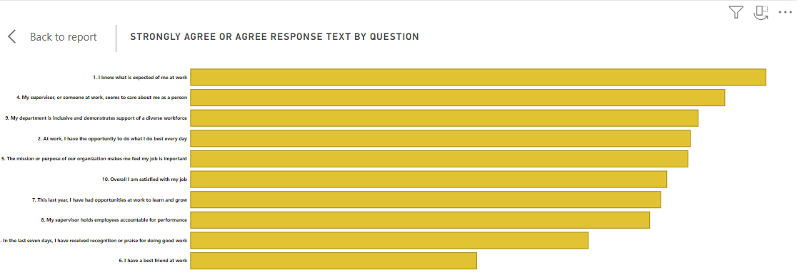

A greater percentage of "Agree and Strongly Agree" responses are found in some departments, such as "Planning and Public Works" and "Sheriff's Department," suggesting that these divisions may have superior management, higher levels of job satisfaction, and alignment with organizational objectives.

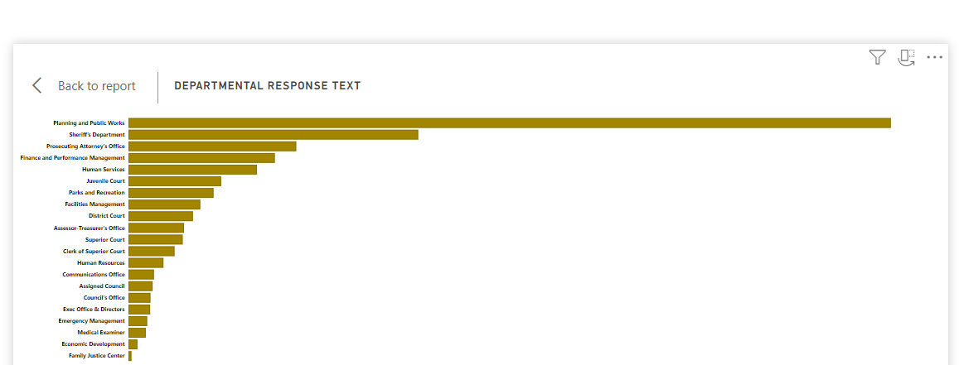

Important Subject Matter for Development:

Interpersonal Connections at Work: The most unfavorable answers regarding question number six, "I have a best friend at work," point to a requirement for programs to strengthen team dynamics and workplace relationships.

Strengthen Integration and Diversity Programs: Considering the differing opinions on inclusiveness (question 9), creating and improving programs and training related to diversity and inclusion may assist to change employee attitudes and create a more encouraging work environment.

Control and Reward: To maintain fairness and openness, performance evaluation procedures and recognition initiatives need to be standardized in light of the conflicting answers to questions 8 and 3, which concern supervisor accountability and recognition, respectively.

Survey Employees Frequently: Use feedback channels and surveys to gauge staff engagement and satisfaction on a regular basis. Utilize the newfound understanding to see patterns, resolve problems, and make informed choices to enhance working conditions.

Through proactive measures to address areas of improvement as indicated by survey data, businesses may enhance general performance at work as well as staff engagement and pleasure

THANK YOU!!